

Name: VANSH GUPTA

Object Oriented Programming (OOP) Laboratory File

Sap ID: 500123239
Enrollment No: R2142230209
Batch: B4

Experiment 6
Packages & Final Keyword

Ensuring Constant Tax Rate Using final
A taxation system requires businesses to calculate GST (Goods and Services Tax) for invoices while ensuring that the tax rate remains unchanged.
Implementation Steps:
- Create a class TaxCalculator with:
  - A final variable GST_RATE = 18.0% (constant tax rate).
  - A final method displayGST() → Prints the tax rate.
- Create another class Invoice that extends TaxCalculator, with:
  - A method calculateTotalWithTax(double amount) → Computes the total amount after applying GST_RATE.
- In the main() method:
  - Test calculateTotalWithTax().
  - Attempt to modify GST_RATE or override displayGST() and observe the compilation error.
Objective:
- Demonstrate how the final keyword ensures that tax rates remain constant across all calculations.

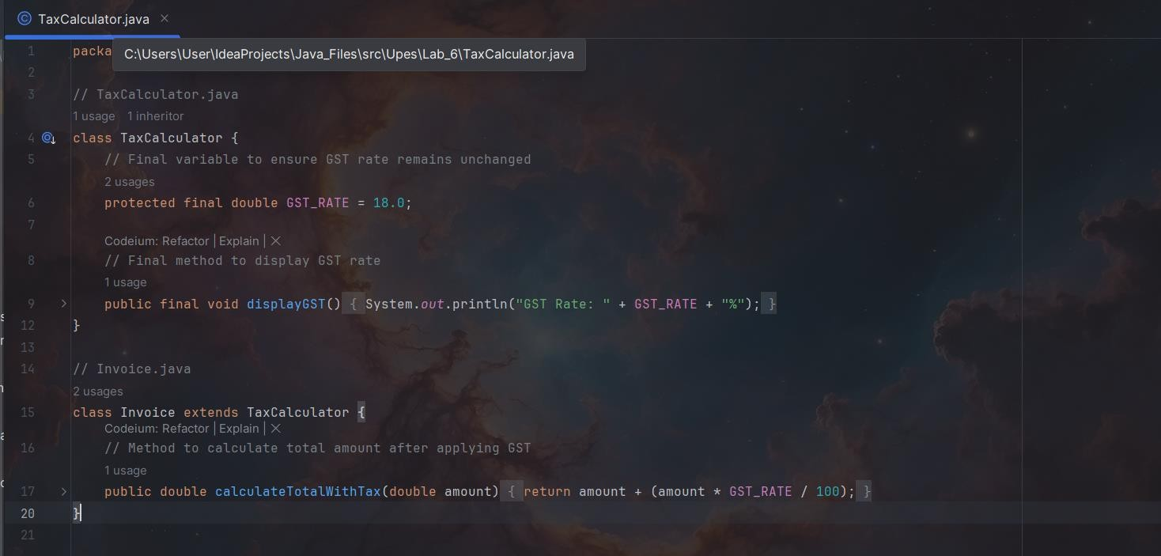

Security System: Preventing Unauthorized Inheritance Using final
A security system requires protection against tampering with authentication mechanisms.
Implementation Steps:
- Create a final class SecuritySystem with:
  - A method authenticateUser(String username, String password) → Verifies user credentials.
- Attempt to create a subclass AdvancedSecurity that extends SecuritySystem and overrides authenticateUser().
- In the main() method:
  - Create an instance of SecuritySystem and test authenticateUser(). Objective:
- Observe the compilation error when attempting to inherit from a final class.
- Explain why a final class cannot be extended, ensuring security in authentication logic.

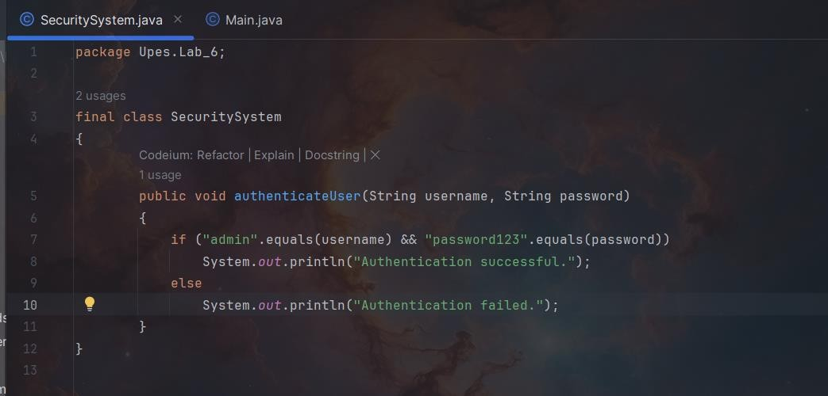

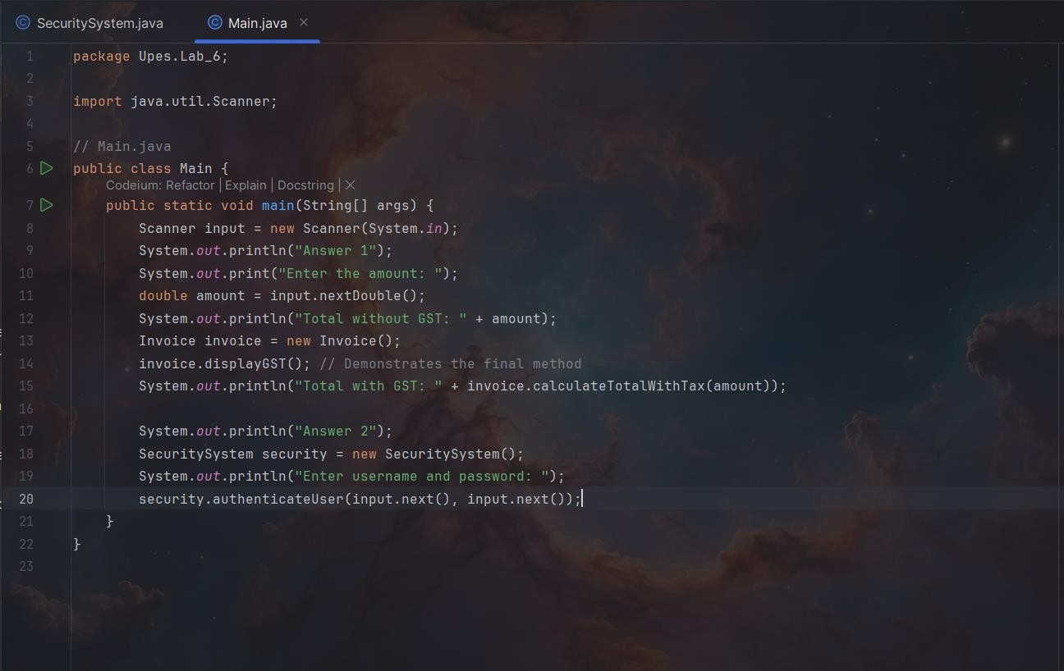

Student Records Management System (Using Packages & Encapsulation)
A Student Records Management System needs to securely store and access student details while controlling data modification.
Implementation Steps:
- Create a package StudentRecords containing: o A class Student with private attributes: studentId, name, grade.
  - A public constructor to initialize attributes.
  - A public method displayStudentInfo() → Prints student details.
- Create another program outside the package that: o Imports StudentRecords. o Creates Student objects and displays their details.
Objective:
- Demonstrate encapsulation:
  - Private attributes cannot be accessed directly.
  - Only public methods allow controlled access to data.

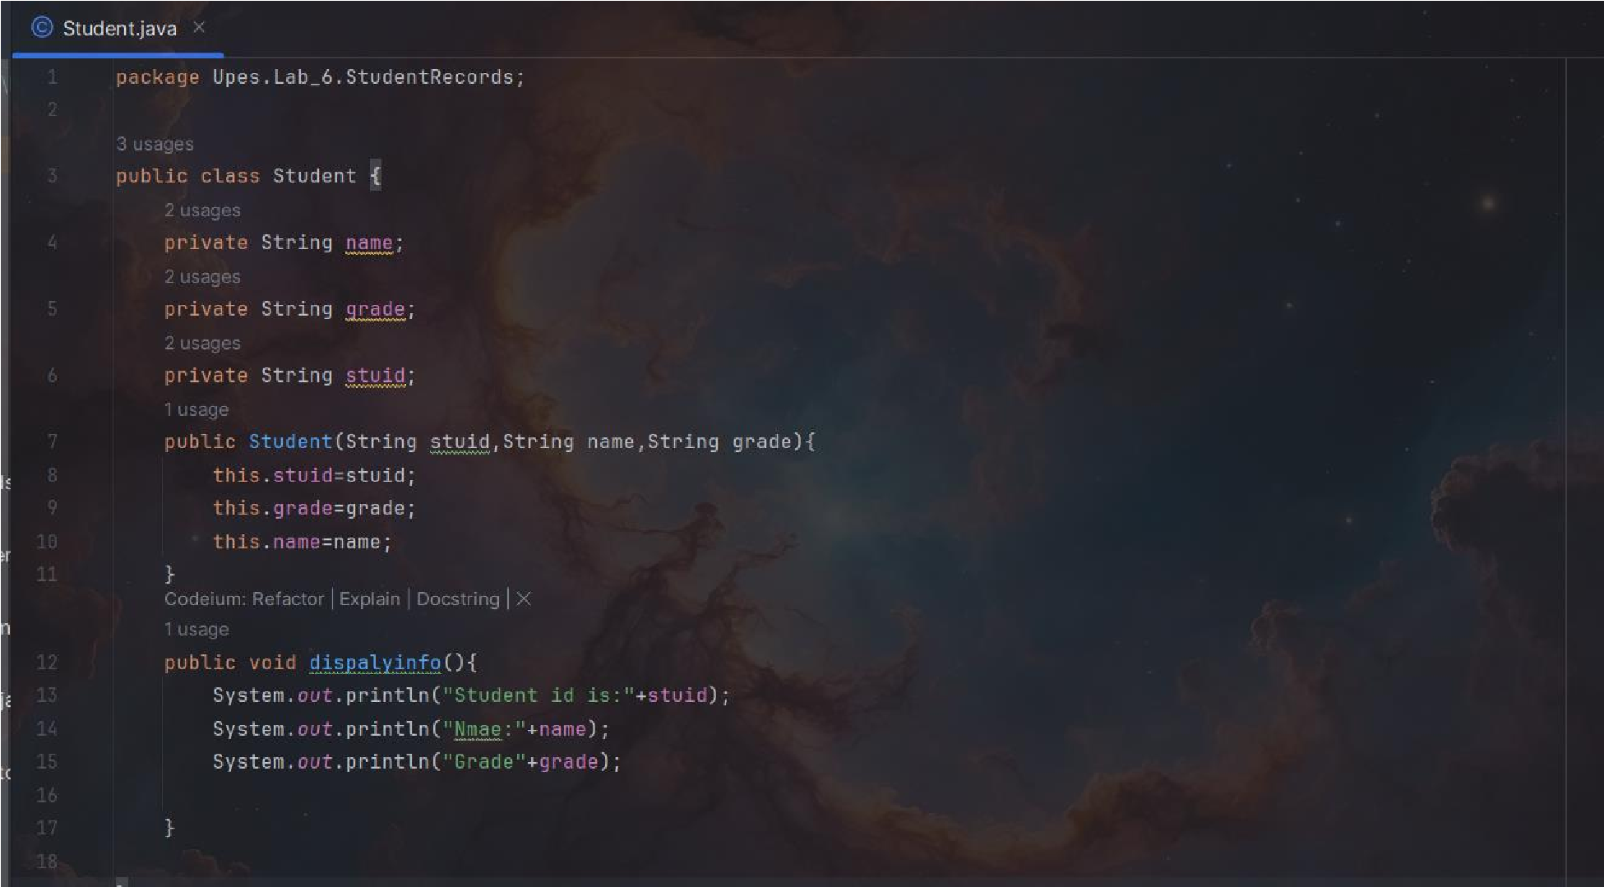

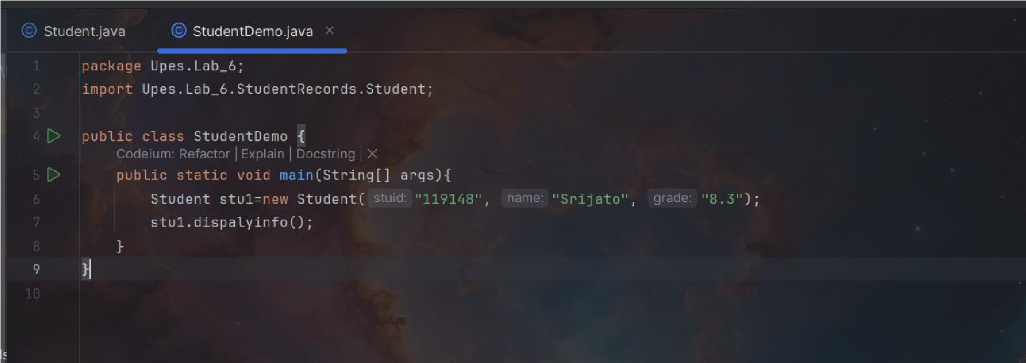

Online Shopping System (Access Control with Packages & Methods)
An E-Commerce System requires secure handling of product inventory and discounts.
Implementation Steps:
- Create a package ECommerce containing a class Product with:
  - Public method getProductDetails() → Retrieves product information.
  - Protected method applyDiscount() → Manages internal discounts.
  - Default-access method updateStock() → Updates inventory (accessible within the same package).
  - Private method calculateProfit() → Computes earnings internally.
- Create another package CustomerPortal containing a class CustomerCart that:
  - Attempts to access all the above methods from an instance of Product. o Observes which methods are accessible and restricted.
Objective:
- Explain how Java’s access control mechanisms ensure that: o Only the right methods are accessible.
  - Sensitive product operations remain protected.

